# How To Setup Meka For the CommanderX16

This document assumes Windows PC without any CC65 Installation

1. Download the CC65 for Windows 32 snapshot <https://sourceforge.net/projects/cc65/files/cc65-snapshot-win32.zip>
2. Copy the entire contents of the download artifact to c:\cc65\
3. Download CommanderX16 Emulator 45 from: <https://github.com/X16Community/x16-emulator/releases/download/r45/x16emu_win64-r45.zip>
4. Copy the contents of the zip to C:\commander
5. Install OSF mount, from this link: https://www.lo4d.com/get-file/osfmount/6cc9b9a1eeb741271568423e28f84625/
6. Add the CC65_INC, LD65_CFG and the LB65_LIB environment variables, with the values as in the screenshot below:  
   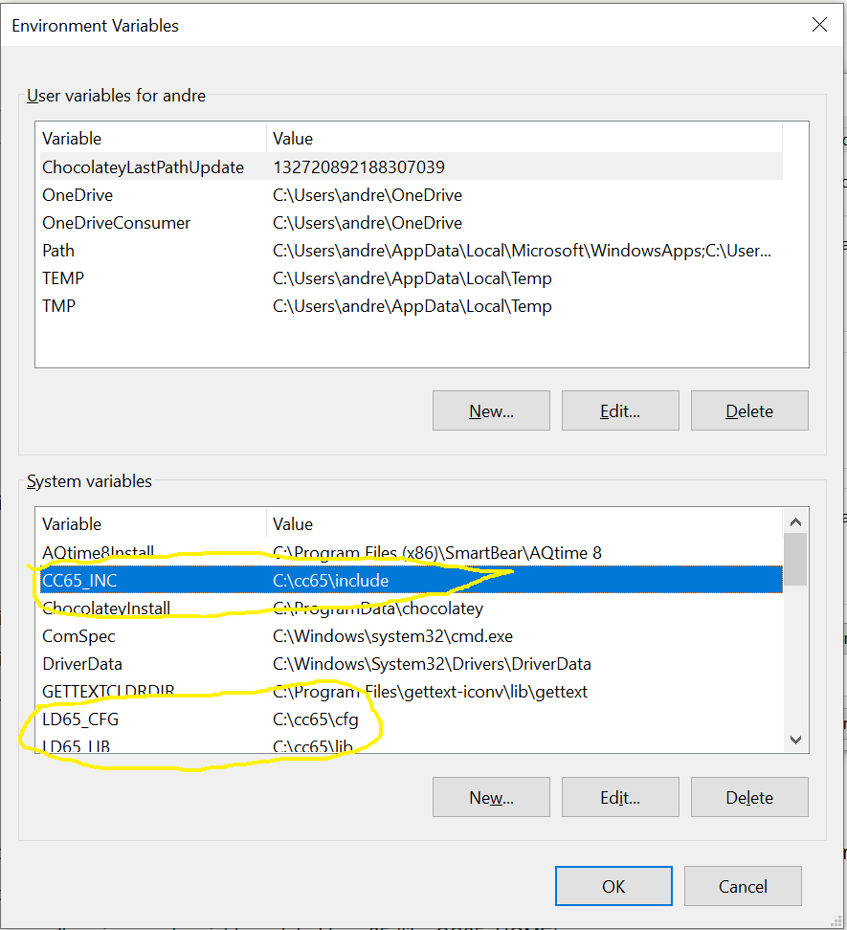
7. Update the ‘PATH’ system environment variable to have the three highlighted entries:  
   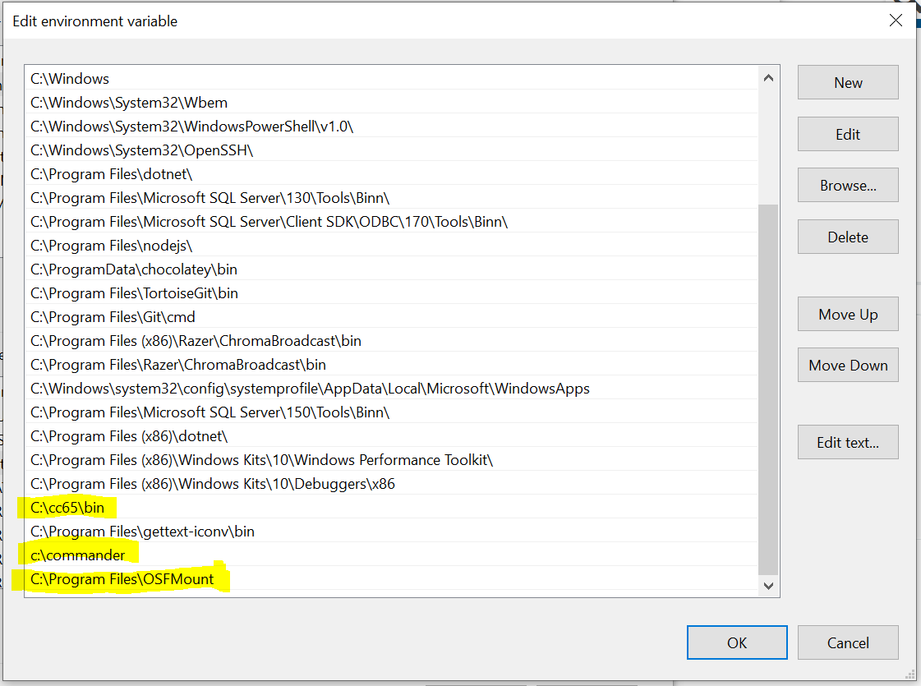
8. Install ‘Chocolatey Individual’, which handles make according to the instructions on; [Chocolatey Software | Installing Chocolatey](https://chocolatey.org/install#individual)
9. Log out to ensure environment variables are recognized
10. In an elevated command prompt run the following: choco install make
11. Download the following: <https://www.dropbox.com/scl/fi/n9fg9cu78p59hvtbw7uub/meka_toUpload.zip?rlkey=wjey7oomungvlztqciydhyspa&st=6003lw39&dl=0> to source folder to C:\meka
12. Download the SDCard images from: <https://www.dropbox.com/scl/fi/0y1k0u99wgzkhkoegare9/sdcardImages.zip?rlkey=v8yi4ihgfjzkee8g4mp57op78&st=vlguhqf9&dl=0> extract the contents and copy them to c:\commander
13. Ensure that the folder c:\temp exists
14. Run tester.exe from: C:\meka\CommanderX16Repo\. Don’t forget to run as admin
15. Agree to install the .NET framework if asked, as this is required for the tester mechanism
16. Rerun tester.exe again and enter the following config values and press test. These values will be remembered, so you won’t see this screen again. They can be updated in cx16TesterConfig.json  
    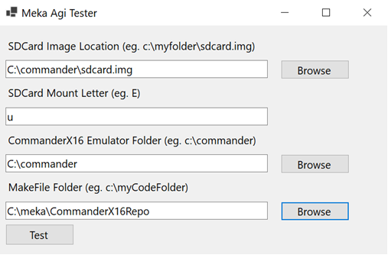
17. Every time code is changed, simply run tester.exe or tester.exe -warp to test your changes in the emulator.
18. To run a different game simply stop the emulator and rename relevant image to ‘sdcard.img’